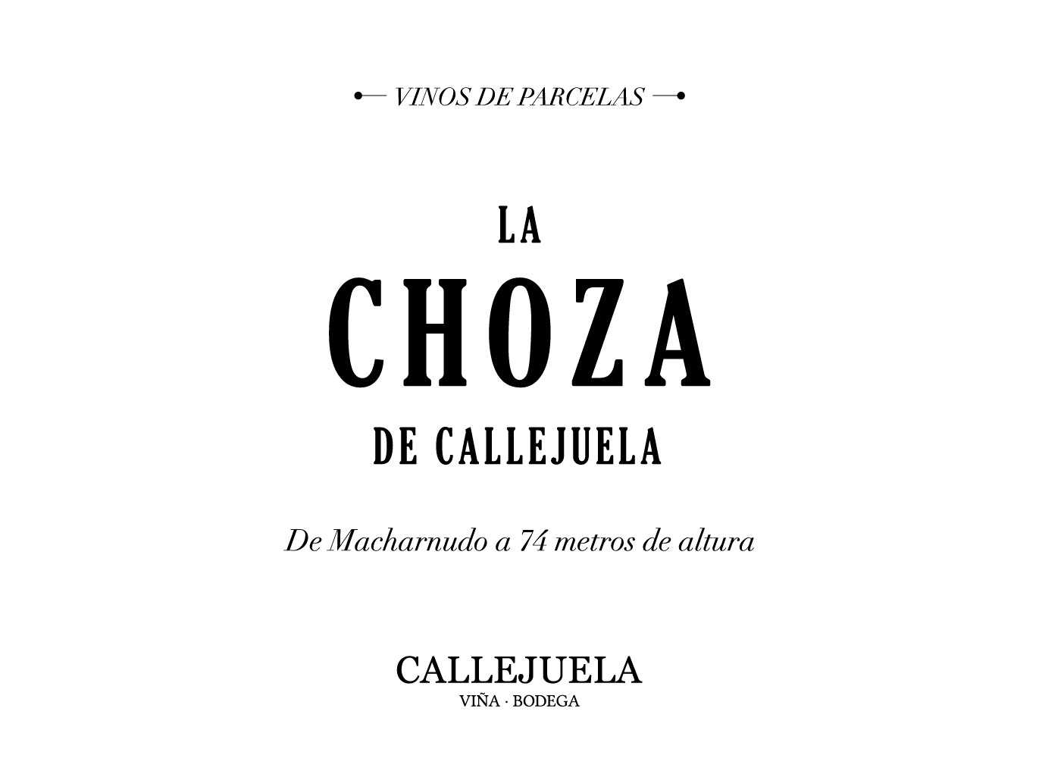Viña Callejuela

“La Choza”

Region: Andalucía
Soil: Albariza Pura
Elevation: 74m
Vinifera: 100% Palomino
Capataz/Winemakers: José and Francisco Blanco Romero

Vineyard: 28 hectares of family owned fruit planted within three vineyard sites of Macharnudo (4ha at 74m) and Añina (8ha at 83m) within Jerez, and Callejuela (16ha at 63m) in Sanlúcar de Barrameda which houses their two tiny bodegas less than two miles from the sea. It is there in the Callejuela vineyard where the two small bodegas on their property store their botas and age their wines.

La Choza is made from un-fortified Palomino must from their 4 ha plot in Macharnudo located in the hills of Jerez. This 4ha Macharnudo pago is their warmest site, often 10 degrees warmer than at the winery in Sanlúcar. This vineyard is their farthest from the sea and less humid.

Production: The harvest is done before those of the fortified wines and pressed more delicately that those that will be fortified. This single vineyard, single variety Palomino is produced from the first grape selection from the Macharnudo pago and is-fermented in ancient Manzanilla Barrels where it sits, untouched, on the lees for 7 months.

Vintage: 2017 was a classic San-luqueño vintage, albeit a bit rainier. Palomino reached optimum ripeness at harvest in early-mid September, weeks after their neighbors. Each pago offered 2,000 bottles of single vineyard ‘parcelario’ wines and everything else was blended into Blanco de Hornillos to produce 5,000 bottles of the pago blend.

Wine: Laser Bright with mineral laden textures and firm structure. Distinct elegance and high toned nerve with grilled citrus fruit and sea shells. Has a funky Chablis like quality and enjoys some air. Complex and exciting, with particularly noticeable Albariza character. The highest in alcohol of the three at 13.5%. Incredible balance.

Total production: 1800 bottles

