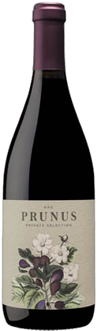

Gota Vinhos

2021 Prunus

Region: Dao
Soil: Granite and clay
Elevation: 200-400m
Vinifera: 80% Jaen, 10% Tinta Roriz, 5% Alfrocheiro, 5% others (co-ferment)
*95pts Decanter

Vineyard
Dry farmed, sustainable/non-certified organic. The small, single vineyards that comprise Prunus are located in the lower elevations of the bowl that is the Dao. While they collect 2200-2400 heat units each vintage, there are cooling winds that come off the mountain-sides to retain natural acids in the wine.

Production
Hand picked fruit, a majority of the lot is destemmed, although there is always whole cluster co-fermentation with particular lots. Native fermentation in stainless steel and foot-tred lagar. 7-28 days skin soak, the wine is pressed, and placed into cement tank and neutral barrel 6 months.

Vintage
The 2021 vintage was typified by dry, hot growing conditions up until mid-Sept harvest, where intermittent rains dictated pick dates. The late harvest mild temperature allowed for Prunus to be picked with acidity and elegance in mind. Fresh, high toned aromatics and textural complexity typify 2021 Prunus, which proves a challenging harvest can yield exceptional wine in the right hands.

Wine
An intense jammy bedrock of blueberry and damson offset with a liverly herbaceous and white pepper lift; succelent and juicy with a long, refreshing finish. Stunning! - 95pts Decanter

UPC: 5 601250 101810

