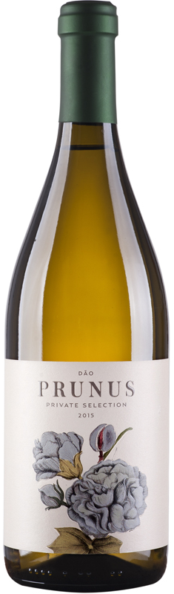

Gota Vinhos

2021 Prunus

Region: Dao
Soil: Granite and clay
Elevation: 200-400m
Vinifera: 50% Encruzado, 15% Malvasia Fina, 15% Bical, 15% Cerceal Branco, 5% others (co-ferment)

Vineyard
Dry farmed, sustainable/non-certified organic. The small, single vineyards that comprise Prunus are located in the lower elevations of the bowl that is the Dao. While they collect 2200-2400 heat units each vintage, there are cooling winds that come off the mountain-sides to retain natural acids in the wine.

Production
Hand picked fruit, some lots are destemmed, crushed and left to soak on their skins for 24 hours, the remaining are whole cluster pressed into cement and stainless tank. Native fermentation, 6 months lees contact before racking into stainless tank for filtration. The wine sees additional aging in bottle before release, 6-12 months.

Vintage
The 2021 vintage was typified by dry, hot growing conditions up until mid-Sept harvest, where intermittent rains dictated pick dates. The late harvest mild temperature allowed for Prunus to be picked with acidity and elegance in mind. Fresh, high toned aromatics and textural complexity typify 2021 Prunus, which proves a challenging harvest can yield exceptional wine in the right hands.

Wine
Complex aromas of salted honeydew melon, fresh sage, peach and starfruit on the nose. The palate is balanced with medium acidity and good fruit intensity. Prunus Branco continues to overdeliver, and is a hidden gem in an up-and-coming region rightfully known for its red wine value.

UPC: 5 601250 102244

