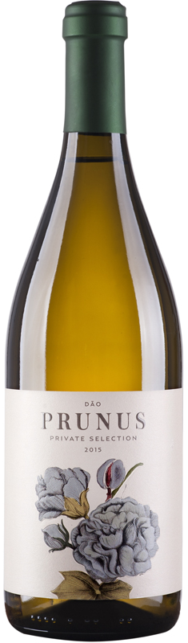

Vinhos Gota

2017 Prunus

Region: Dão
Soil: Granite and clay
Elevation: 300-400m
Vinifera: 50% Encruzado, 15% Malvasia Fina, 15% Bical, 15% Cerceal Branco, 5% others (co-ferment)

Vineyard
Dry farmed, sustainable/non-certified organic. The small, single vineyards that comprise Prunus are located in the lower elevations of the bowl that is the Dão. While they collect 2200-2400 heat units each vintage, there are cooling winds that come off the mountain-sides to retain natural acids in the wine.

Production
Hand-picked fruit, some lots are destemmed, crushed and left to soak on their skins for 24 hours, the remaining are whole cluster pressed into cement and stainless tank. The wine sees additional aging in bottle before release, 6-12 months.

Vintage
While the Douro suffers from heat and vine stress over the summer, the Dão is able to mitigate drought via the natural insulation of the surrounding hillsides. In 2017, they harvested earlier than ever before during the last week of August. It was a very healthy vintage with no diseases, stress or sickness in the vineyards. Growers who picked early were rewarded with fresh wines with natural stone fruit aromas and great drinkability.

Wine
‘Prunus’ means stone fruit. Here, you get white peach, kefir lime, apricot and starfruit on the nose. The palate is elegantly sewn with a light lanolin-like texture but offers bracing acidity at the same time. Powerful aromas from Malvasia, matched with layers and complexity from Encruzado (cement aging), and the Bical/Cerceal offers acidity for aging. - 5000 cases.
UPC: 5 601250 102244

